***1st Step:*** Click on the ***Manage Jenkins*** link in the left menu bar, as highlighted below:

***2nd Step:*** Under the ***System Configuration*** section, click on the ***Manage Plugins*** options:

***3rd Step:*** Under the Plugin Manager, click on the ***Available*** tab (marker 1) and search for the ***maven*** plugin (marker 2). It will show the ***Maven Integration*** plugin as a result

***4th Step:*** Select the checkbox in front of the ***Maven Integration plugin*** and click on the ***Install without restart*** button:

***5th Step:*** Once the plugin installs successfully, click the checkbox to restart Jenkins:

***6th Step:*** After the restart of Jenkins, the Maven Jenkins plugin will be installed successfully and ready for configuration.

**After the installation of the Maven Jenkins plugin, let's see how we can configure and integrate the Maven with Jenkins:**

**How to integrate Maven with Jenkins?**

The reason behind integrating Maven with Jenkins is so that we can execute Maven commands through Jenkins as we will majorly use Maven for Java projects. Hence, ***JDK*** also comes as a pre-requisite for this setup. So, let's fir quickly see how to can specify the java path in Jenkins:

### ***How to setup Java Path in Jenkins?***

Maven integration with Jenkins starts with setting up the Java path in Jenkins. Kindly follow the below steps to setup Java path in Jenkins:

***Step 1:*** Open the Jenkins and go to Jenkins Dashboard. After that, click on the ***Manage Jenkins*** link as shown below:

As soon as we click on the ***"Manage Jenkins"*** link, we will redirect towards the Manage Jenkins page in which we can see different types of options, and from here, we can see the ***"Global Tool Configuration"*** option.

***Step 2:*** Now click on the ***Global Tool Configuration*** link as highlighted below:

As soon as we click on Global Tool Configuration, we will be redirected to the Global tool configuration page to specify different configurations.

***Step 3:*** After that, we need to set the JDK path in Jenkins. To set the JDK path in Jenkins, please follow the below-highlighted steps:

* *Click on the****Add JDK****button. Kindly note that by default,****"Install Automatically"****will be checked, so since we are going to use the JDK installed in our local machine,****"Install automatically"****will install the latest version of JDK, and you will also need to provide credentials to download relevant JDK.*
* *Give JDK's name as we gave as JDK 1.8, as this is currently installed in my machine.*
* *Give the path of JDK in JAVA_HOME textbox.*

After this, the *JDK* path is properly set up in *Jenkins.* Now, the next task is to set up the *Maven* path in *Jenkins.*

### ***How to setup Maven Path in Jenkins?***

In the previous section, we saw how to set up the *Java* path in *Jenkins,* and now, in this section, we will set up the *Maven* path in *Jenkins.* Please follow the below steps to set up the *Maven* path in *Jenkins.*

1. *Click on the****Add Maven****button. Kindly note that by default,****"Install Automatically"****will be checked, so we will uncheck it because we don't want that Jenkins will automatically install the latest version of Maven.*
2. *Give the name of Maven as we gave as****Maven 3.6,****as this is the version set up in my machine.*
3. Give the path of Maven in the ***MAVEN_HOME*** textbox.
4. Click on the ***Save*** button.

Now that we have configured both Java and Maven in Jenkins, Let's see how to create and execute a Maven project in Jenkins?

## What is a Maven project in Jenkins?

Jenkins provides a particular job type, which explicitly provides options for configuring and executing a Maven project. This job type is called the ***"Maven project."*** Let's see how we can create a Maven project in Jenkins and run the same.

### ***How to create a Maven project in Jenkins?***

We know that the ***pom.xml*** file is the heart of Maven projects. For demonstration purposes, we already created a maven project, which is pushed into the [***GitHub repository.***](https://github.com/toolsqa17061989/SetupBuildJob) Kindly visit the link [***Understanding GitHub***](https://www.toolsqa.com/git/github/) to understand more about Git and GitHub. For creating a Maven project in Jenkins, follow the steps as mentioned below:

***Step 1:*** Firstly, we need to create a job. To create this, click on the ***"New Item"*** option.

***2nd Step:*** Now, do the following steps to create a new maven project:

1. *Give the Name of the project.*
2. *Click on the****Maven project.****Kindly note that If this Maven Project option is not visible, we need to check whether the****"Maven Integration"****plugin is installed in Jenkins. If not installed, then install it and restart Jenkins. For more details, please refer to our article*[***"Install Jenkins"***](https://www.toolsqa.com/jenkins/install-jenkins/).
3. *Click on the****OK****button.*

***3rd Step:*** Describe the project in the description section.

Now, go to the further sections like ***Source Code Management*** and ***Build Triggers*** section.

***4th Step:*** Select the Git option in ***"Source Code Management "*** as per our requirement because we will pull our Maven project from the GitHub repository. **Use the provided github repo.**

https://github.com/pradeeprpin/TomcatMavenApp.git

Also, if we need to select the ***"GitHub hook trigger for GITScm polling” option*** in the ***"Build Triggers"***  section, we will trigger our build with the help of webhooks.

***5th Step:*** Now perform the following highlighted steps to move further:

1. *Firstly, give the relative path of****pom.xml****in the****Root POM****textbox, as we do have the pom.xml at the root of the project, so we directly provided the file's name.*
2. *Secondly, type****"clean install"****in the****Goals and options****textbox as****"maven clean,"******"maven install,"****as well, as****"maven test"****are the maven commands while running maven build but here****"clean install"****command is sufficient to trigger build from Jenkins.*
3. *Finally, click on the****Save****button.*

So, our *Maven project* setup finishes and is ready to run. In the further subsection, we will see how to execute a *Maven* project in *Jenkins.*

Also, if we need to select the ***"GitHub hook trigger for GITScm polling"***  option in the ***"Build Triggers"***  section, we will trigger our build with the help of webhooks.

***5th Step:*** Now perform the following highlighted steps to move further:

1. *Firstly, give the relative path of****pom.xml****in the****Root POM****textbox, as we do have the pom.xml at the root of the project, so we directly provided the file's name.*
2. *S*econdly, type **"clean install"** in the **Goals and options** textbox as **"maven clean,"** **"maven install,"**  as well, as **"maven test"** are the maven commands while running maven build but here **"clean install"** command is sufficient to trigger build from Jenkins.
3. *Fi*nally, click on the ***Save*** button.

So, our Maven project setup finishes and is ready to run. In the further subsection, we will see how to execute a Maven project in Jenkins.

### ***How to execute a Maven project in Jenkins?***

As our maven project is already setup in the previous section, we are now ready to execute it. After setup, a Maven project is similar to other job types in Jenkins. Jenkins provides multiple ways to execute jobs. Apart from the manual execution, a few of the options to automatically executing the jobs are highlighted below:

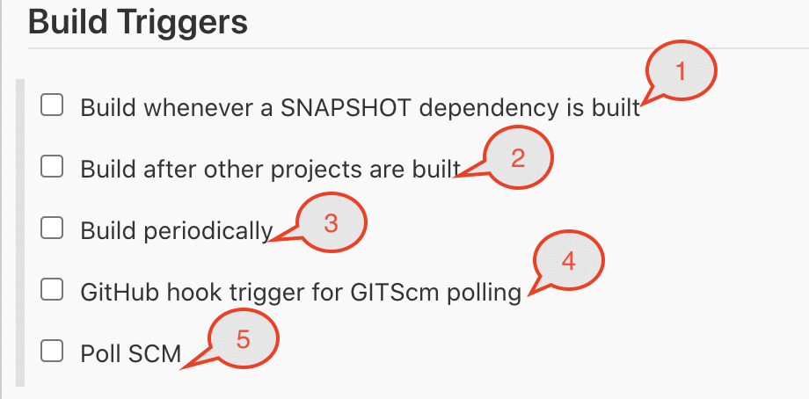

You can select one or all of the above-mentioned options to trigger the build automatically. Let's understand under what all conditions these options will trigger the build:

| ***Build Trigger Option*** | ***Behavior*** |
| --- | --- |
| *Build whenever a SNAPSHOT dependency is built* | If checked, Jenkins will parse the POMs of this project and check if any of its snapshot dependencies are built on this Jenkins. If so, Jenkins will set up a build dependency relationship so that whenever the dependency job builds, and a new SNAPSHOT jar creates, Jenkins will schedule a build of this project.This is convenient for automatically performing continuous integration. Jenkins will check the snapshot dependencies from the <dependency> element in the POM, as well as <plugin>s and <extension>s used in POMs. |
| *Build after other projects are built* | Set up a trigger so that new build schedules for this project when some other projects finish building. This is convenient for running an extensive test after a build is complete, for example.This configuration complements the ***"Build other projects"*** section in the ***"Post-build Actions"*** of an upstream project but is preferable when you want to configure the downstream project. |
| *Build periodically* | This feature is primarily for using Jenkins as a CRON replacement, and it is ***not ideal for continuously building software projects.*** When people initially start continuous integration, they often use the idea of regularly scheduled builds like nightly/weekly that they use this feature. However, the point of continuous integration is to start a build as soon as a change is made to provide quick feedback. To do that, you need to hook up the SCM change notification to Jenkins. |
| *GitHub hook trigger for GITScm polling* | If Jenkins receives/ gets PUSH GitHub hook from repo defined in the Git SCM section, it will trigger Git SCM polling logic. In fact, polling logic belongs to Git SCM. |
| *Poll SCM* | Configure Jenkins to poll changes in SCM. Note that this will be an expensive/ cost-incurring CVS operation, as every polling requires Jenkins to scan the entire workspace and verify it with the server. |

You can select any of these options for the auto-execution of *Jenkins* jobs. We will cover the details of all these options in future articles.

## Key Takeaways:

* Maven is a powerful build management tool for Java projects to assist with a complete life cycle build framework. Moreover, its basis is the concept of ***POM*** (Project Object Model) in which all configurations can be done with the help of a ***pom.xml*** file.
* Additionally, we can download binary zip according to our OS and save it in any directory. After that, we need to set up a maven path in the environment variables section in the system and the Global tool configuration in Jenkins.
* Finally, after setting up, we need to write pom.xml  text in the build section and command ***"clean install"*** to drive maven functionalities.
* Moreover, we can trigger build automatically in Jenkins either manually or various Build trigger options available with Jenkins.